Python Programming (05CS2104)
Lab Manual (2025-26)
Program: M.Sc. (Cyber Security & Cyber Law)
Semester: 1
Name of the Student: Vasu Parmar
Enrolment No.: 92600565007

INDEX

Lab | Program | Date | Remarks | Signature
1 | Python Program to Print Hello World. | 1-8-26
2 | Python program to do arithmetical operations | 1-8-26
3 | Python program to swap two variables | 1-8-26
4 | Python Program to Find the Factorial of a Number | 1-8-26
5 | Python Program to Print the Fibonacci sequence | 1-8-26
6 | Python program to print the elements of an array | 1-8-26
7 | Python program to print the largest element and smallest element in an array | 1-8-26
8 | Python program to add two matrix using array and function | 1-8-26
9 | Python program to print the sum of all elements in an array | 1-8-26
10 | Python Program to concatenate two strings | 1-8-26
11 | Python Programs to perform various operations on Strings using functions
12 | Python Programs to demonstrate use of list and various functions of it
13 | Python Programs to demonstrate use of tuple and various functions of it
14 | Python Programs to demonstrate the use of dictionary and various functions of it
15 | Python Programs to demonstrate use of various arguments which can be passed to functions
16 | Python Program to demonstrate the use of class
17 | Python program to demonstrate the use of methods
18 | Python programs to demonstrate the use of various forms of inheritance
19 | Python programs to demonstrate use of modules
20 | Python programs to demonstrate the use of exception handling
21 | Python programs to demonstrate the use of file handling
22 | Python Programs to demonstrate the use of various modes of files.
23 | Python programs to demonstrate the use of regular expression
24 | Python programs to demonstrate the use of database using mysql
25 | Python Program to demonstrate the use of DataFrames in python
26 | Python Programs to demonstrate different ways of creating DataFrames
27 | Python Programs to create Pie chart
28 | Python Programs to create histogram
29 | Python Programs to create bar graph
30 | Python Programs to create Line graph
31 | Python Programs to work with Python Libraries useful for Cyber security. Program to generate hash values of a string using hashlib library.
32 | Python Program using socket — Simple Port Scanner
33 | Python Program using re — Detect Emails Using Regular Expressions
34 | Python Program using os Library — Check Files in a Directory
35 | Python program for whois lookup
36 | Python program for Ping Scanner shows ip up or down

Enrollment/Roll No: 92600565007

Practical No. 1

Aim/ Objective: Python Program to Print Hello World.

Source Code:
#Name: Vasu Parmar
#Enrollment: 92600565007

#Q.1 Python Program to Print Hello World.

print("Hello World")

Output:
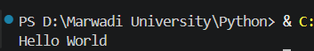

Conclusion: This program introduces the absolute foundation of Python syntax, demonstrating how to use the built-in print() function to display basic textual data directly to the console output.

Enrollment/Roll No: 92600565007

Practical No. 2

Aim/ Objective: Python program to do arithmetical operations

Source Code:
#Name: Vasu Parmar
#Enrollment: 92600565007

#Q.2 Python program to do arithmetical operations

num1 = int(input("Enter the First number: "))
num2 = int(input("Enter the Second number: "))

print("The addition is :) ",num1+num2)
print("The substraction is :) ",num1-num2)
print("The multiplication is :) ",num1/num2)
print("The division is :) ",num1*num2)
print("The modulus is :) ",num1%num2)

Output:
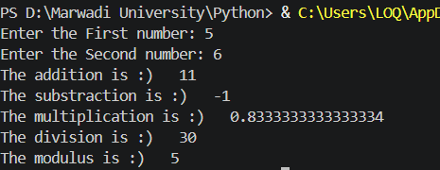

Conclusion: This script shows how Python handles math using standard arithmetic operators (+, -, *, /) to calculate values and store numerical results inside basic variables.

Enrollment/Roll No: 92600565007

Practical No. 3

Aim/ Objective: Python program to swap two variables

Source Code:
#Name: Vasu Parmar
#Enrollment: 92600565007

#Q.3 Python program to Swap two variables

num1 = int(input("Enter the 1st number: "))
num2 = int(input("Enter the 2nd number: "))

print(f"before swapping the values are num1: {num1} num2: {num2}")

num1,num2=num2,num1

print(f"After swapping the values are num1: {num1} num2: {num2}")

Output:
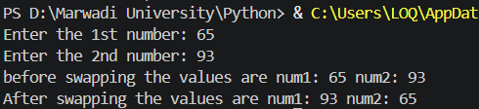

Conclusion: This problem teaches logic and memory storage by showing why a tracking variable (temp) is needed to safely trade values between two data locations without overwriting them.

Enrollment/Roll No: 92600565007

Practical No. 4

Aim/ Objective: Python Program to Find the Factorial of a Number

Source Code:
#Name: Vasu Parmar
#Enrollment: 92600565007

#Q.4 Python program to find factorial of number

num = int(input("Enter the number : "))

fact=1
for i in range (1,num+1):
fact *= i
print("The factorial of given number is : ",fact)

Output:
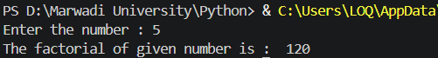

Conclusion: This code demonstrates a sequential loop calculation, showing how a single running product variable can repeatedly multiply growing numbers together to find a final mathematical total.

Enrollment/Roll No: 92600565007

Practical No. 5

Aim/ Objective: Python Program to Print the Fibonacci sequence

Source Code:
#Name: Vasu Parmar
#Enrollment: 92600565007

#Q.5 Python program to find fibonacci series

n=int(input("Enter the number: "))

a=0
b=1
for i in range (n):
a,b=b,a+b
print(a)

Output:
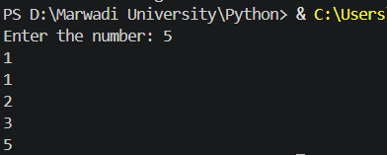

Conclusion: This exercise highlights variable updating and tracking, where two distinct numbers (a and b) pass changing values to each other dynamically to build a step-by-step sequence

Enrollment/Roll No: 92600565007

Practical No. 6

Aim/ Objective: Python program to print the elements of an array

Source Code:
#Name: Vasu Parmar
#Enrollment: 92600565007

#Q.6 Python program to print the elements of an array

arr = [10, 20, 30, 40, 50]

for i in arr:
print(i)

Output:
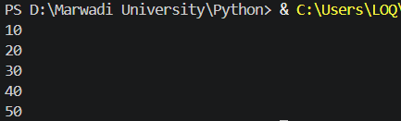

Conclusion: This script teaches array navigation, showing how a basic iterative loop sequentially unpacks a list to isolate and inspect elements one item at a time from start to finish.

Enrollment/Roll No: 92600565007

Practical No. 7

Aim/ Objective: Python program to print the largest element and smallest element in an array

Source Code:
#Name: Vasu Parmar
#Enrollment: 92600565007

#Q.7 Python program to print the largest element and smallest element in an array

arr = [23, 5, 89, 45, 12, 7]

largest = arr[0]
smallest = arr[0]

for i in arr:
if i > largest:
largest = i
if i < smallest:
smallest = i

print("Largest element:", largest)
print("Smallest element:", smallest)

Output:
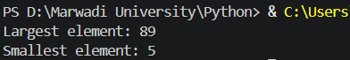

Conclusion: This program teaches conditional data filtering, using simple if comparisons inside a scanning loop to evaluate list items and track the current extreme values.

Enrollment/Roll No: 92600565007

Practical No. 8

Aim/ Objective: Python program to add two matrix using array and function

Source Code:
#Name: Vasu Parmar
#Enrollment: 92600565007

#Q.8 Python program to add two matrix using array and function

#Using array
a= [[1,2,3],[4,5,6],[7,8,9]]
b= [[9,8,7],[6,5,4],[3,2,1]]

for i in range (len (a)):
for j in range (len(a[0])):
print(a[i][j]+b[i][j], end=" ")
print("")

#Using Function
def matrix_addition():
a= [[1,3,2],[5,4,6],[8,7,9]]
b= [[8,9,7],[4,6,5],[3,1,2]]

for i in range (len (a)):
for j in range (len(a[0])):
print(a[i][j]+b[i][j], end=" ")
print("")

matrix_addition()

Output:
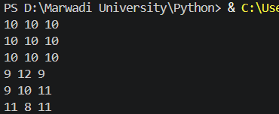

Conclusion: This structure demonstrates multi-dimensional indexing, utilizing a nested loop layout (a loop inside a loop) to target corresponding row and column intersections across distinct data grids.

Enrollment/Roll No: 92600565007

Practical No. 9

Aim/ Objective: Python program to print the sum of all elements in an array

Source Code:
#Name: Vasu Parmar
#Enrollment: 92600565007

#Q.9 Python program to print the sum of all elements in an array

arr = [10, 2, 30, 4, 50]

sum = 0

for i in arr:
sum += i

print("Sum of all elements:",sum)

Output:
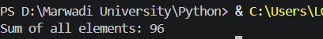

Conclusion: This problem highlights iterative value aggregation, using a linear loop to visit list elements sequentially and add their values to a single running total tracking variable.

Enrollment/Roll No: 92600565007

Practical No. 10

Aim/ Objective: Python Program to concatenate two strings

Source Code:
#Name: Vasu Parmar
#Enrollment: 92600565007

#Q.9 Python Program to concatenate two strings

s1= "hello"
s2= "world"

print(s1+" "+s2)

Output:
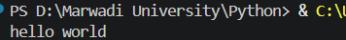

Conclusion: This logic shows how Python handles text combination, using the addition sign (+) as a simple text joining tool to merge individual pieces of string data together.

